Agriculture Farm Management System (AFMS)

01_GitHub_Repository
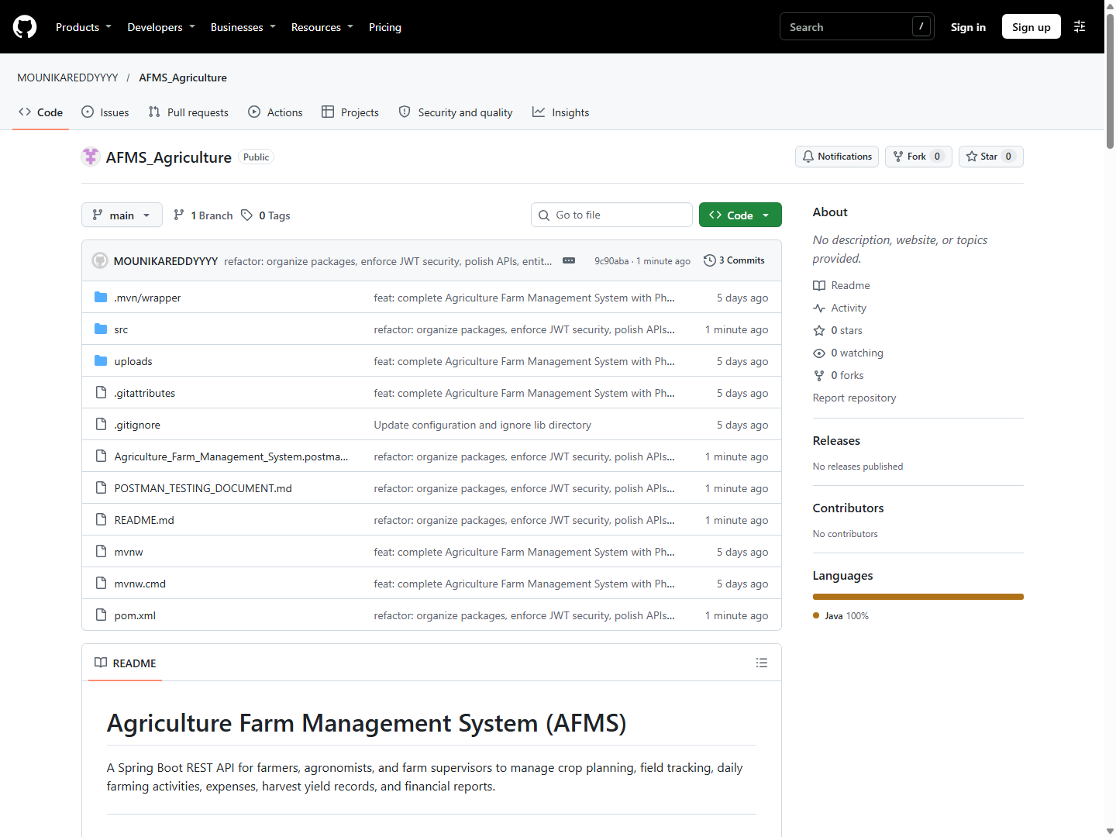
01_GitHub_Repository

02_README
02_README

03_Swagger_API_Documentation
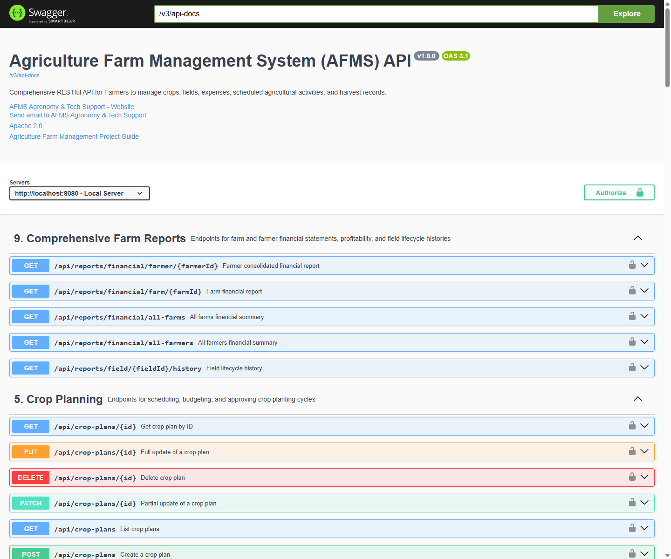
03_Swagger_API_Documentation

04_Farmer_API (Postman — Attach Your Screenshot)
Run 1. Farmer Management → GET - List All Farmers or POST - Create Farmer in Postman against
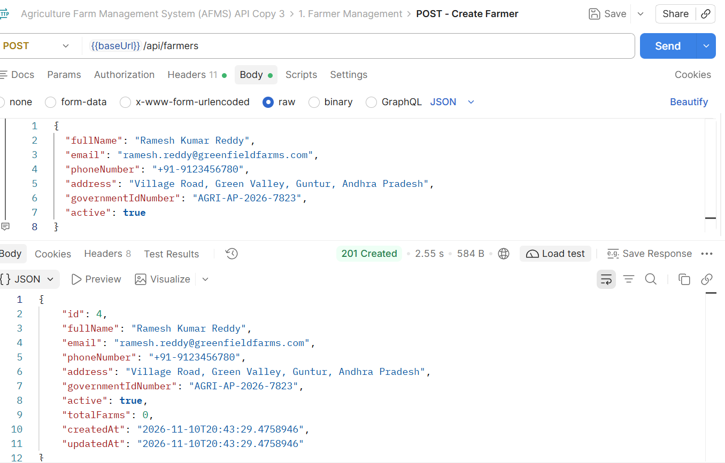
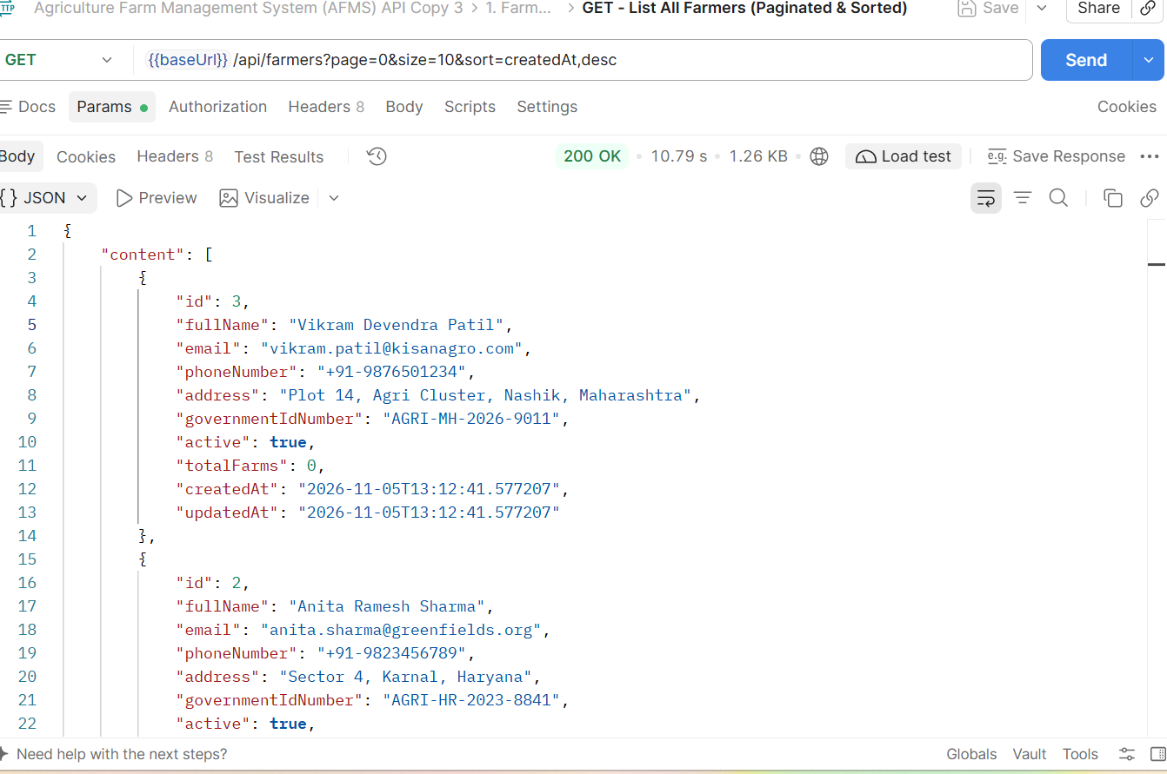

05_Pagination (Postman — Attach Your Screenshot)
Run GET http://localhost:8080/api/farmers?page=0&size=2 (or GET - List All Farmers in Postman) to show pageNumber, pageSize, totalElements, totalPages, last.
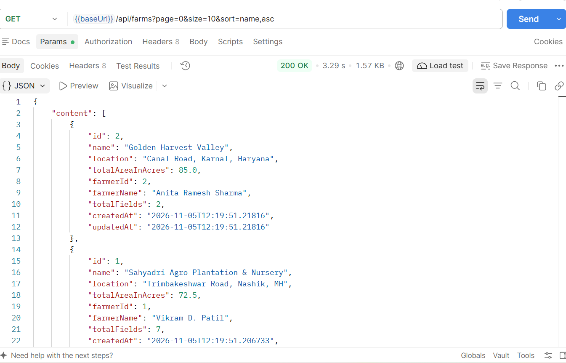

06_Sorting (Postman — Attach Your Screenshot)
Run GET http://localhost:8080/api/farmers?page=0&size=5&sort=fullName,asc in Postman to show
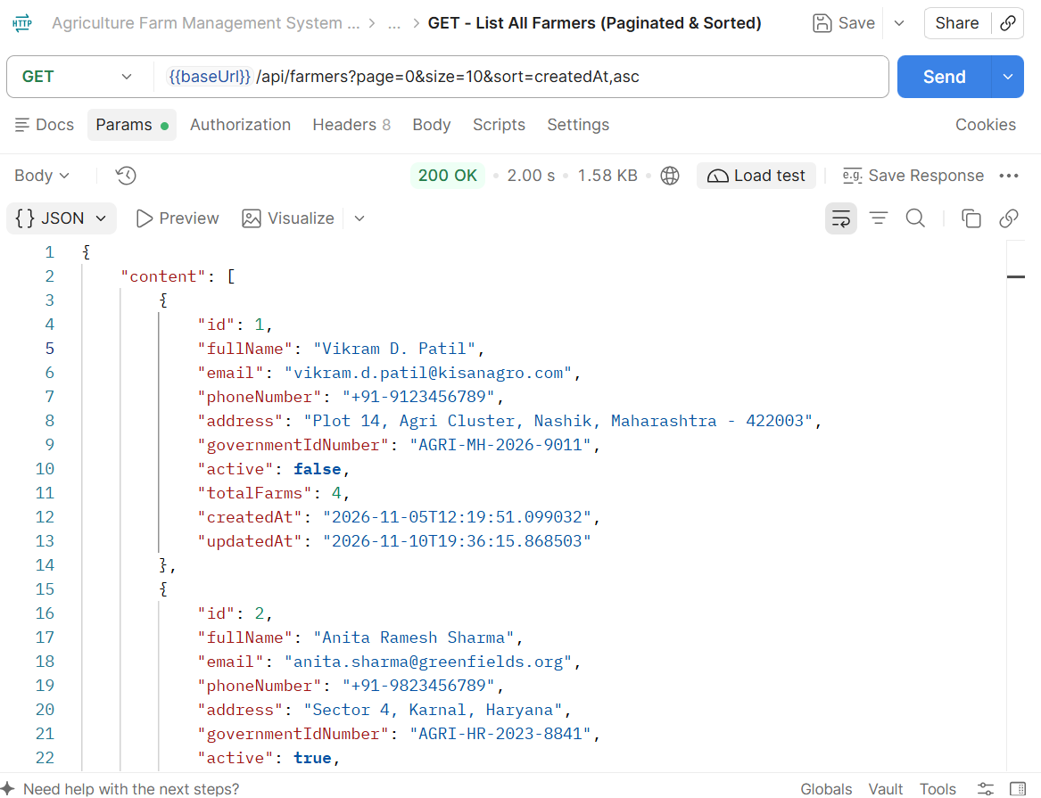

07_File_Upload_Download (Postman — Attach Your Screenshot)
Run 11. File Handling & CSV Data Exports → POST - Upload Agricultural Document (form-data, key file) and
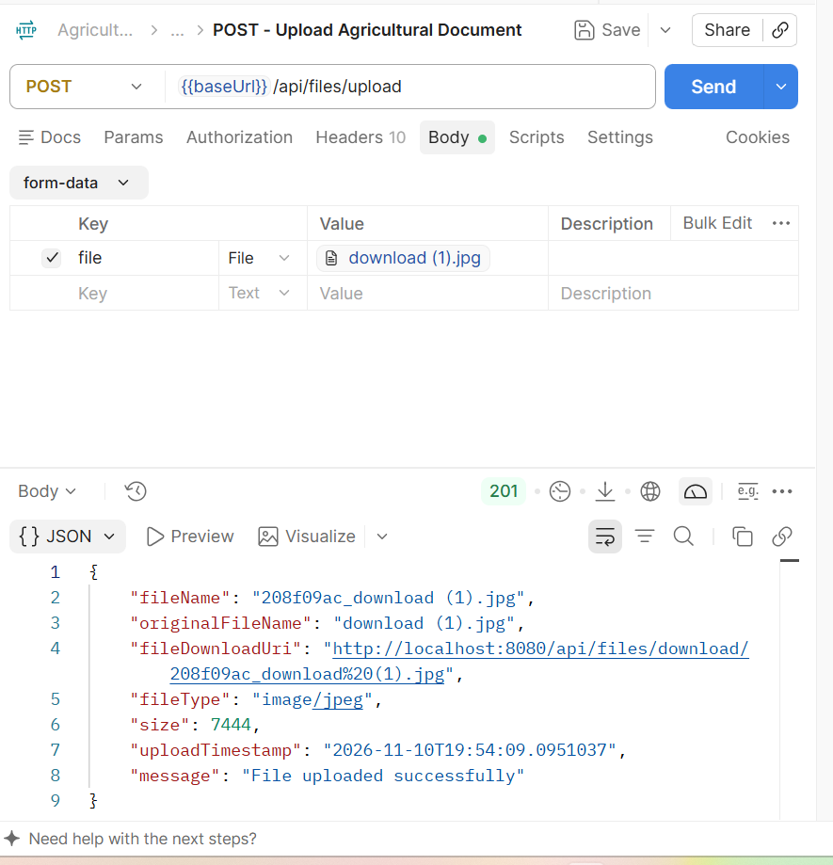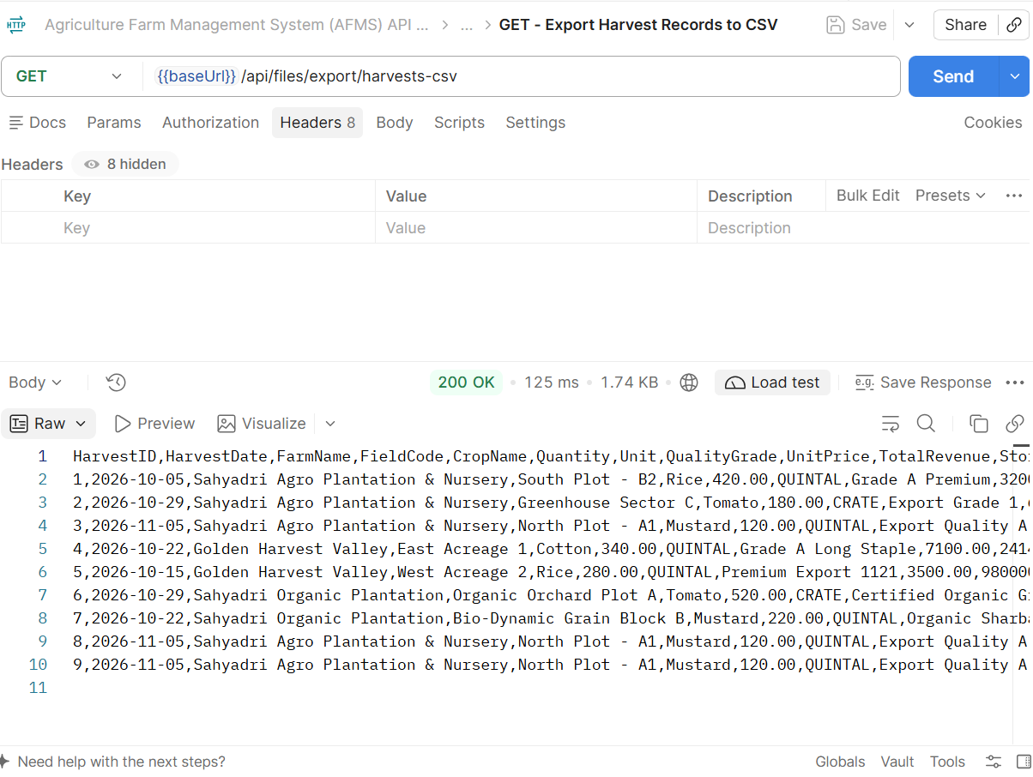
GET - Download Stored Document (8c5f9b17_download.jfif) in Postman.

08_Security (Postman — Attach Your Screenshot)
Capture both:
- GET http://localhost:8080/api/farmers without Authorization header → 401 Unauthorized
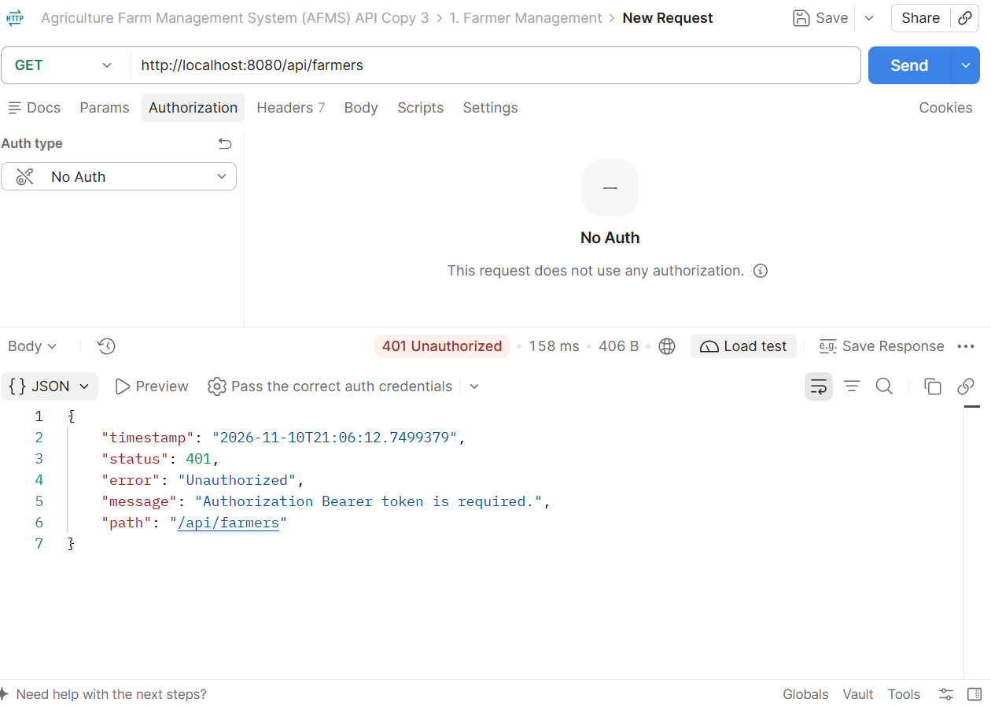
- POST http://localhost:8080/api/auth/login (admin / admin123) → 200 OK returning signed Bearer JWT (eyJ...)
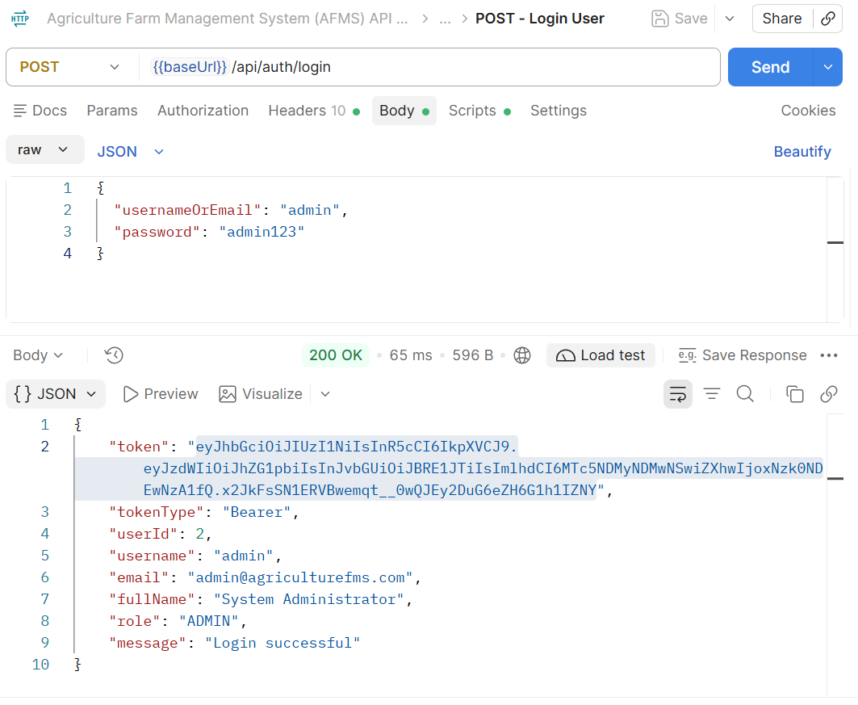

09_MySQL_Tables (MySQL Workbench / CLI — Attach Your Screenshot)
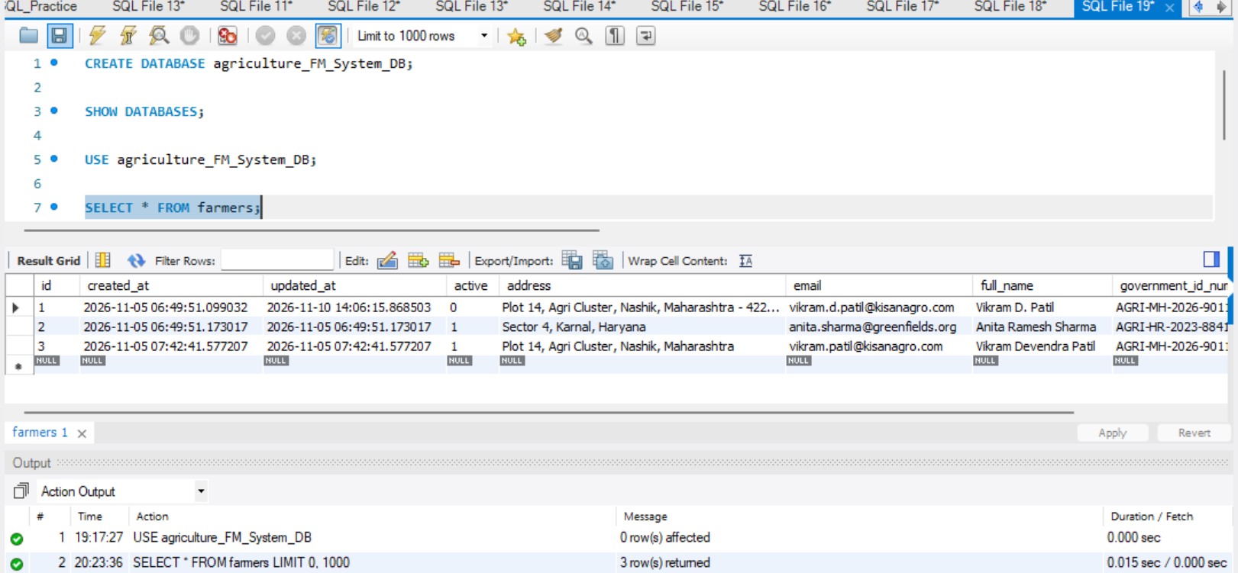
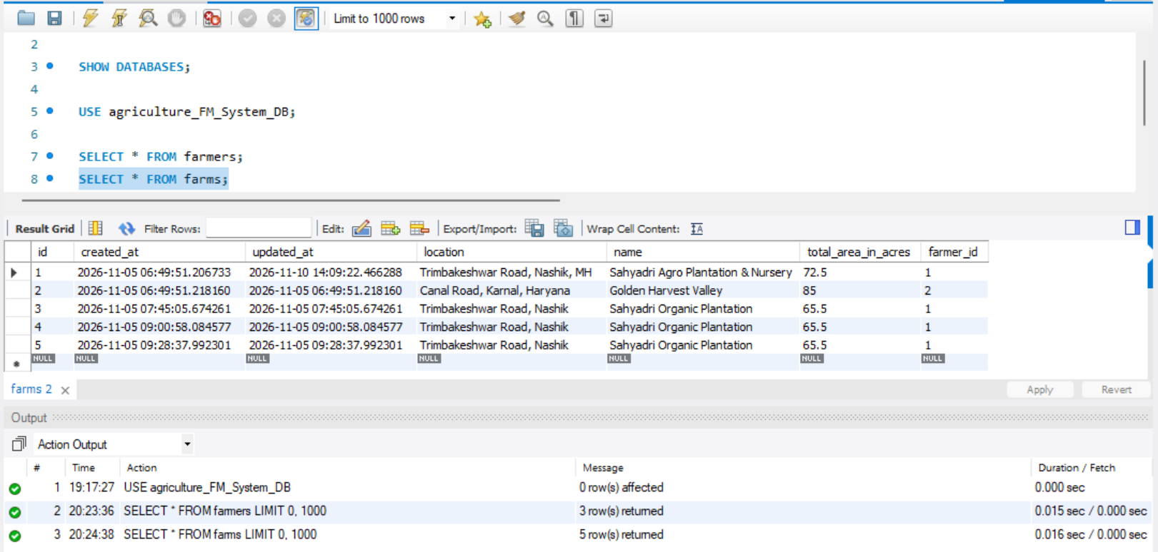
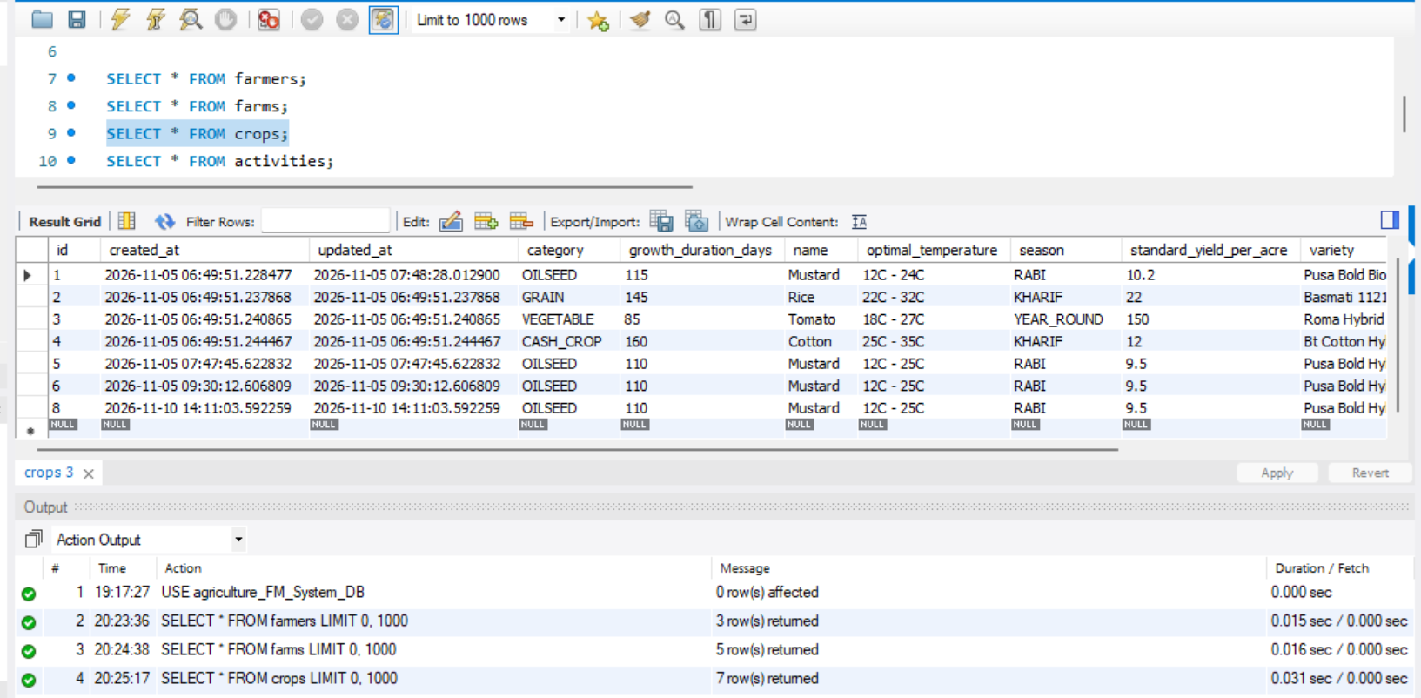
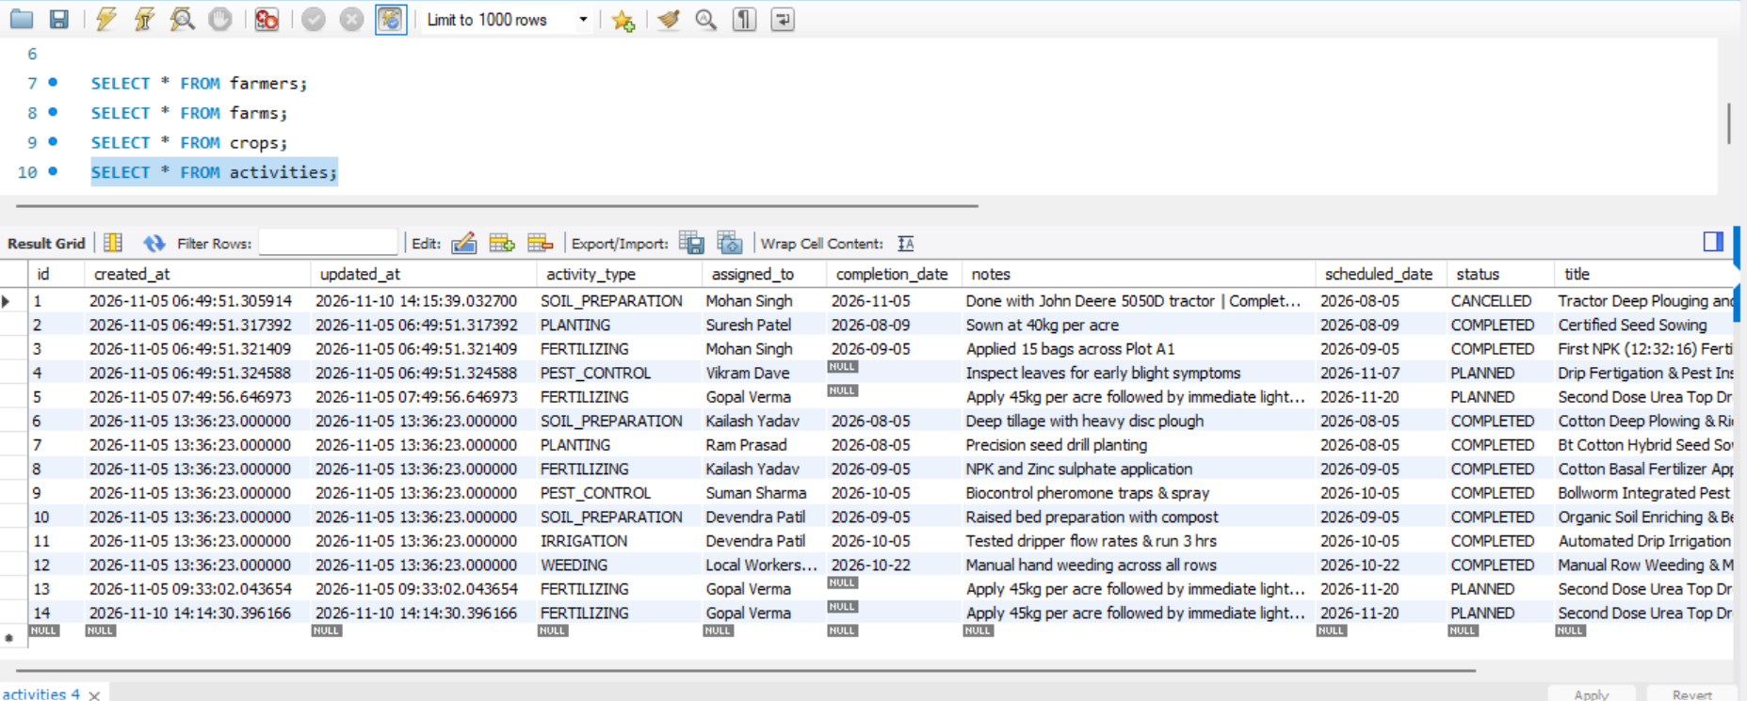
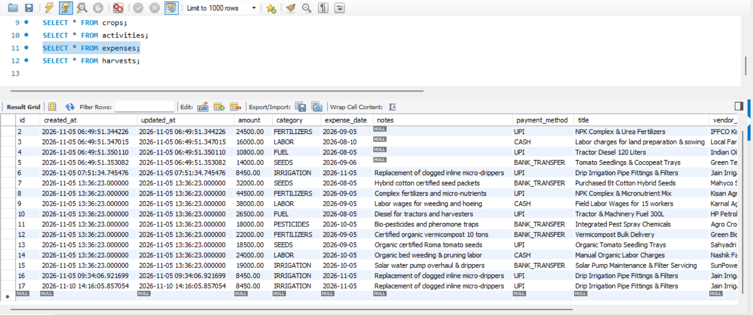
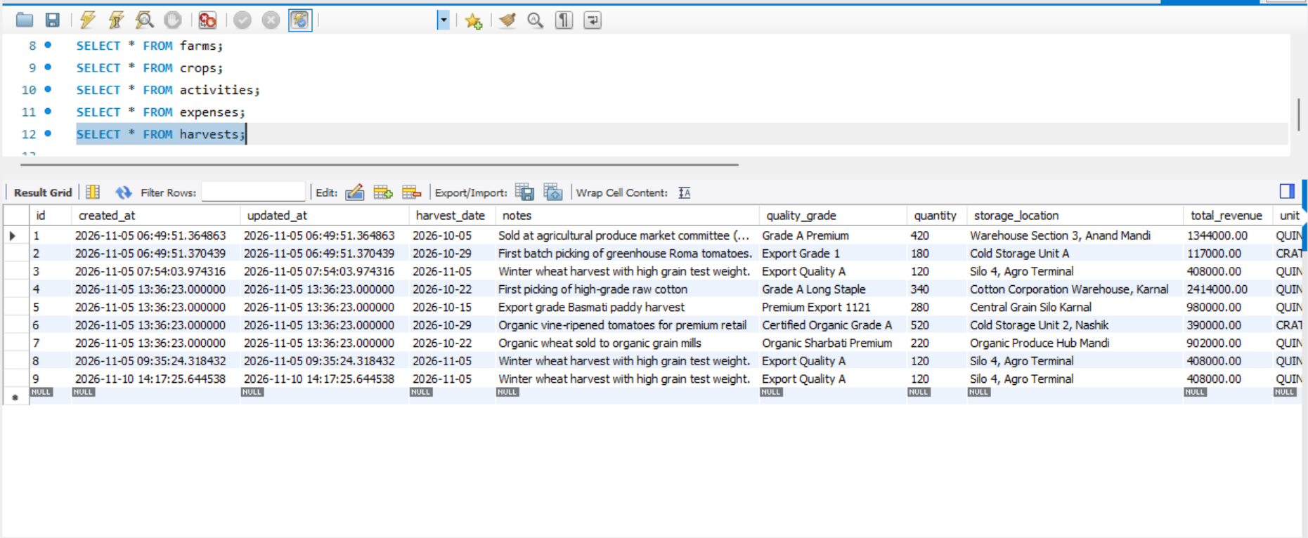

10_Entity_Relationship
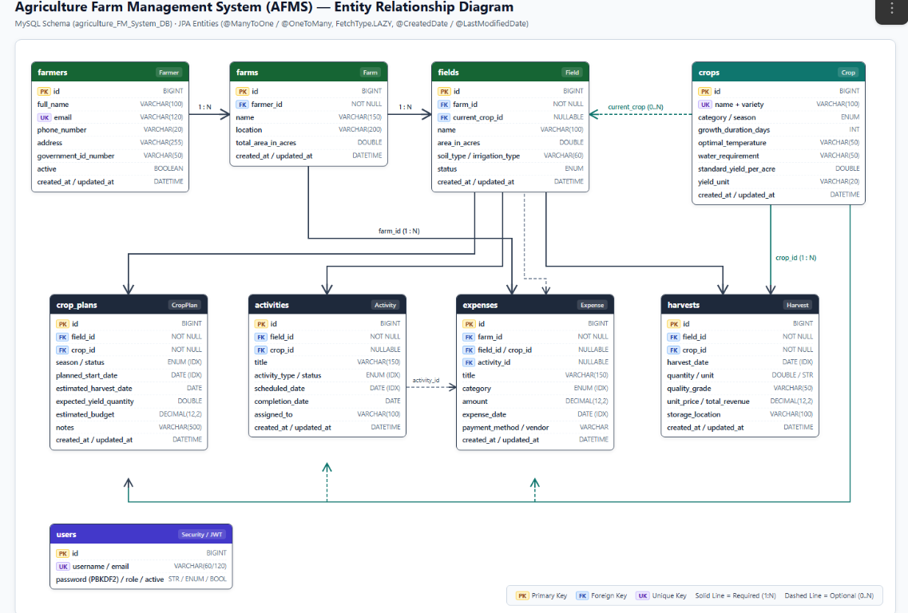

11_Actuator_Metrics
11_Actuator_Metrics
Custom Agricultural Actuator Endpoint (/actuator/agriculture)

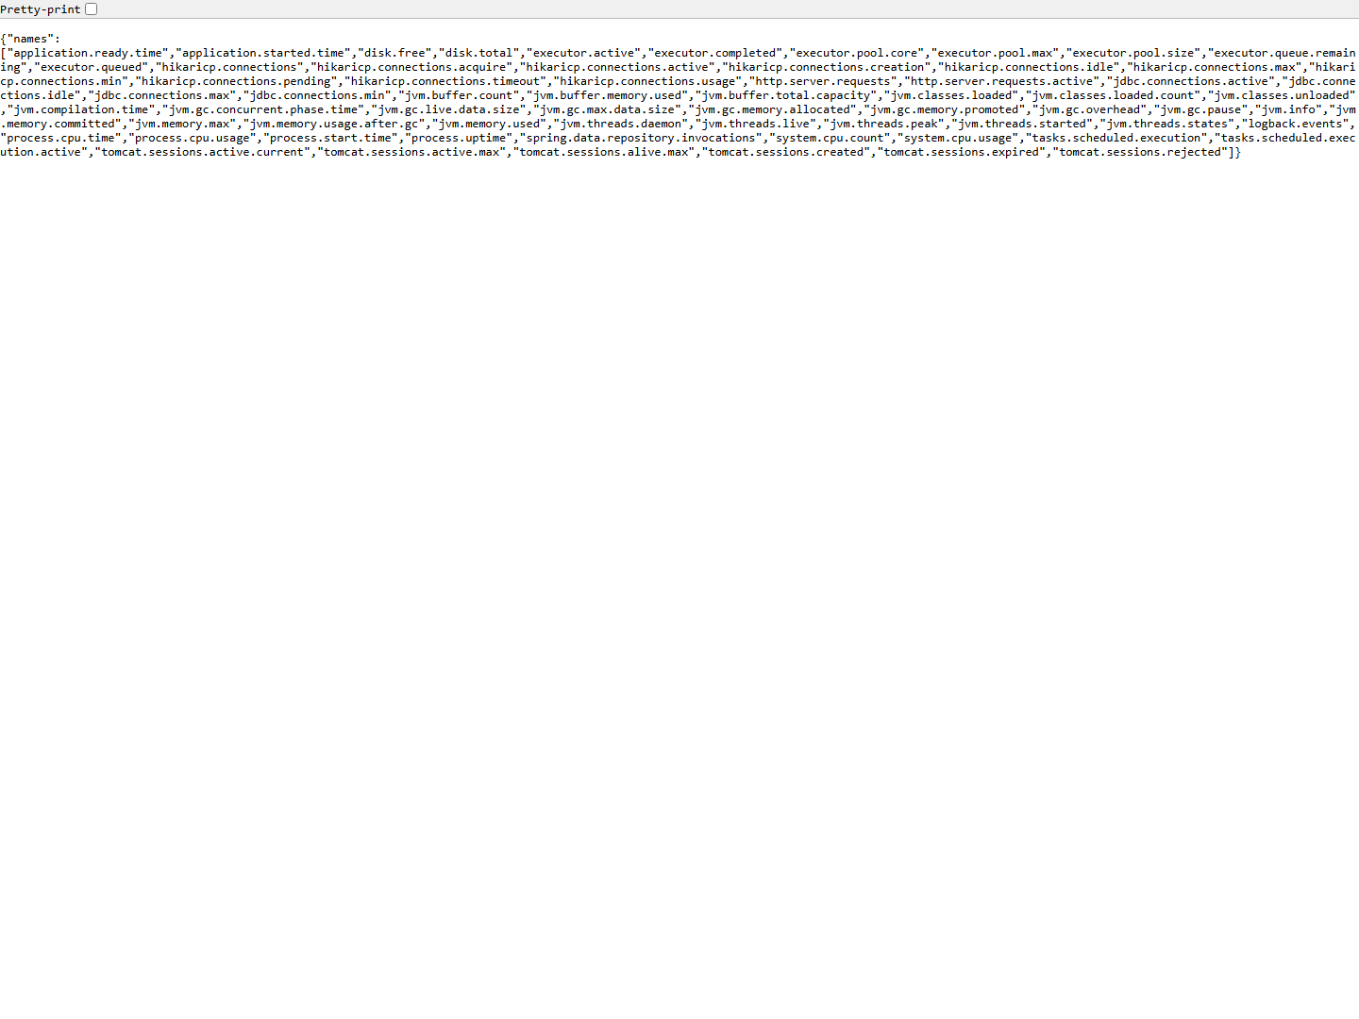
11_Actuator_Agriculture
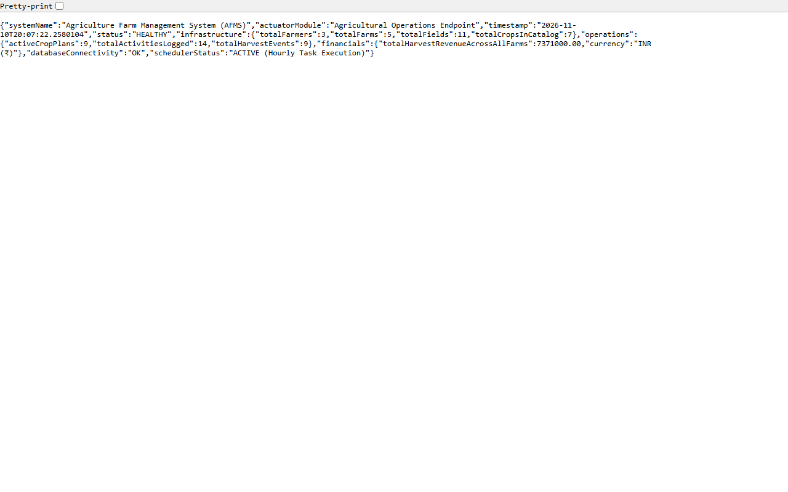

12_Console_Logs


